


Deferral Options

Deferral Options

Create and visualize Expenses and Revenues deferrals in their respective menus and forms for Portuguese Chart of Accounts.
- Distinguish the asset from Expense or Revenue.

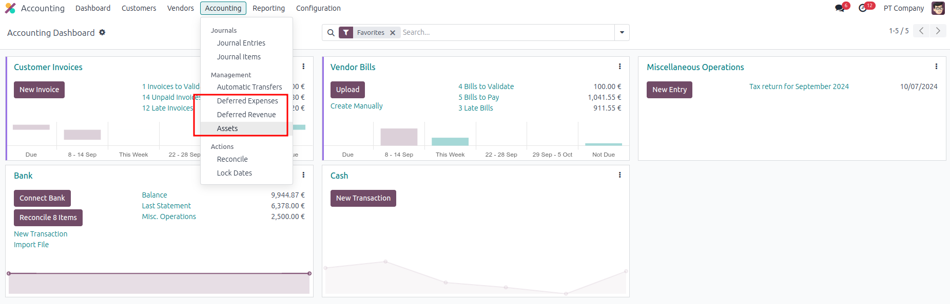
- Direct access to the type of Asset created from Bill or Invoices.

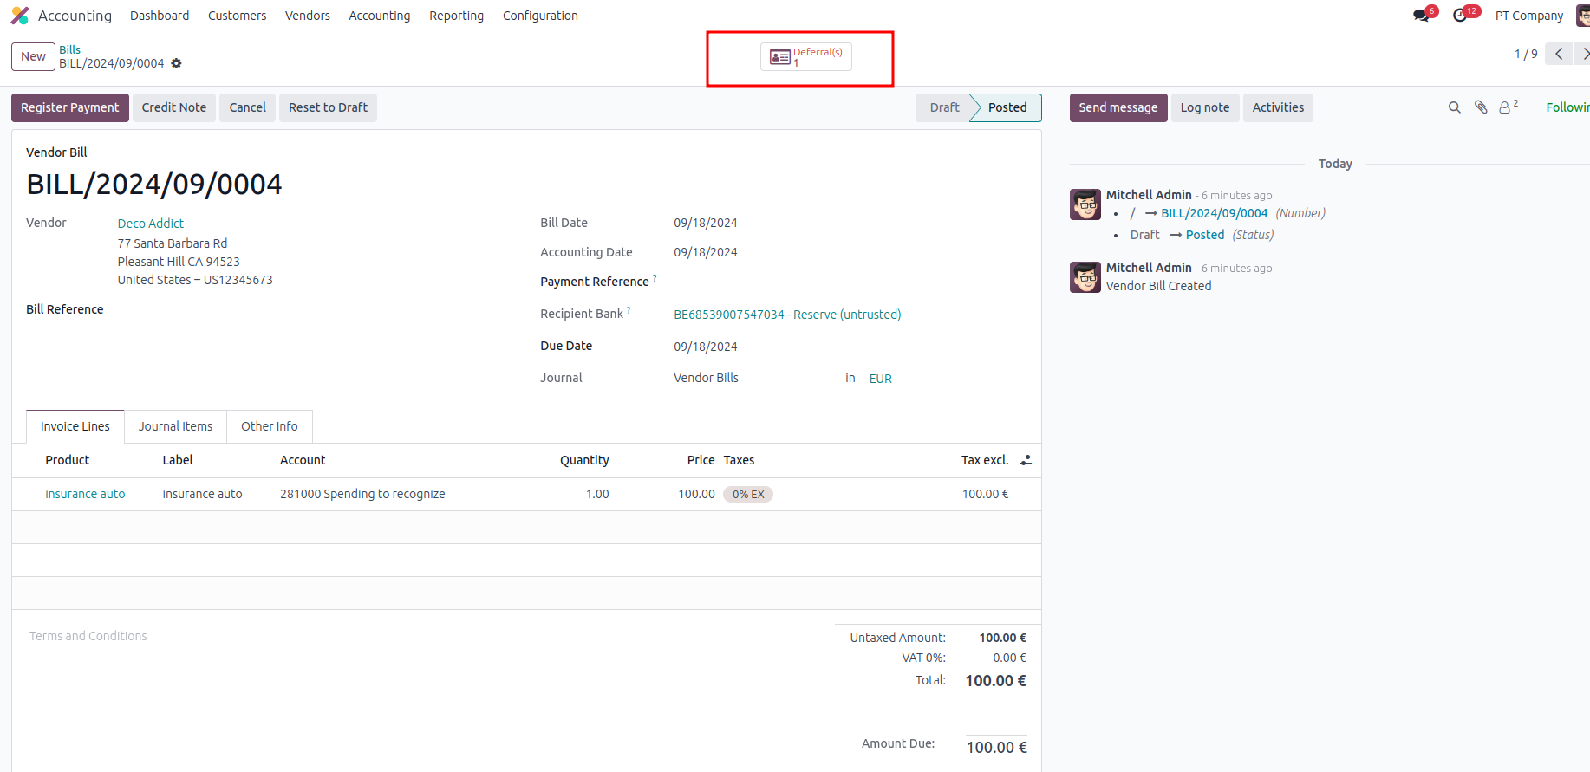

- Dedicated menu to create Expense or Revenue Assets
